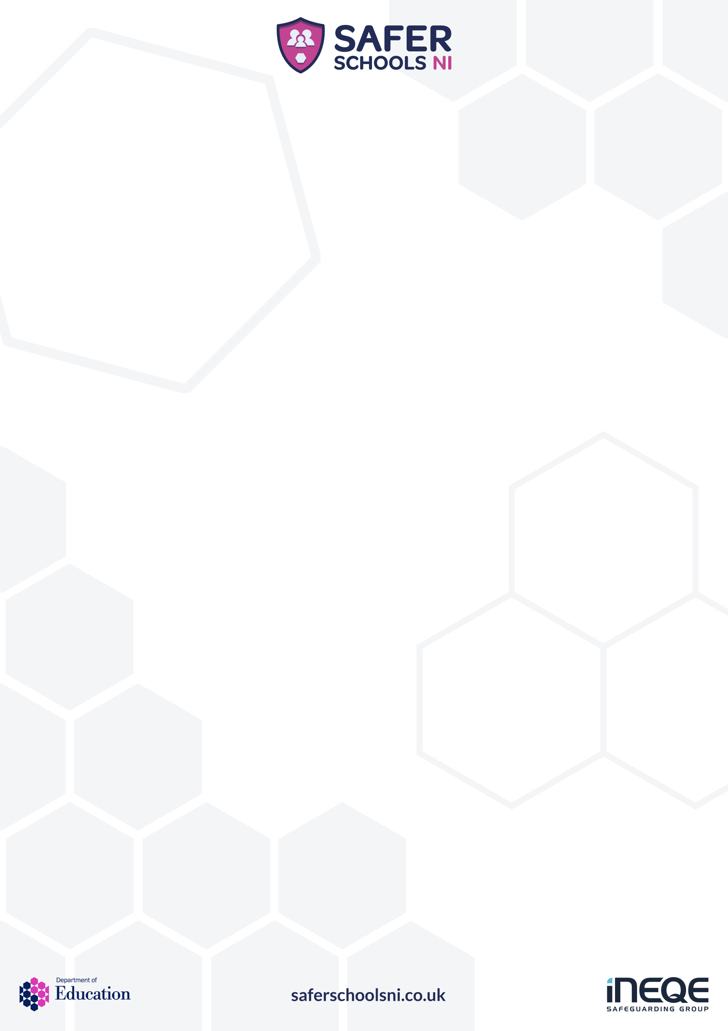
EDUCATE – EMPOWER – PROTECT
Hello Parents and Carers,
On average, only 40% of parents strongly agree that they know enough to help their child stay safer online. (Ofcom, 2025).
In an effort to help support you in this space, we are inviting you to participate in the Digital Proficiency Course, alongside our staff and pupils, through our Safer Schools App.
This unique whole-school course, created by safeguarding professionals at INEQE Safeguarding Group and Safer Schools NI, is designed to educate and empower everyone within the school community to be safer in a digital world.
All learning is built on creating foundational principles, covering the 5 C’s of Online Risk (Content, Contact, Conduct, Commerce, and Cyber Security), including parental controls, Artificial Intelligence, Age Restrictions, and Catfishing. The course is intended to raise awareness, increase your confidence and provide practical advice on how to help your child stay safer online.
As a school, we’re encouraging our staff, our pupils and you, the parents and carers, to actively participate. Your involvement is a crucial part for us to successfully achieve the status of a Certified Safer School. In gaining this certification together, we will publicly show our collective commitment to safeguarding in a digital world.
You can access the video-based course in your Safer Schools NI App on Web and Mobile (under 'Digital Proficiency') from 5th February 2026. You will receive a certificate of completion upon finishing the final test, and the school will be notified of your result.
We’ve attached a quick start guide to set up your account if you have not already done so. You will need the following Parent/Carer Access Code:
9035
Thanks in advance for participating. For parents and carers who wish to know more information on the course and Safer Schools NI, please visit their website.
Kindest Regards,

J Scullion

