JCQ INFORMATION FOR CANDIDATES 2025-2026
These instructions are for examinations held between 01/09/2025 and 31/08/2026.
It is very important that you access each of the documents below by scanning each QR code. You must read and ensure that you understand the instructions provided.
QR CODE | TITLE
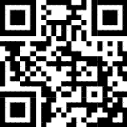 | Information for candidates  Written examinations
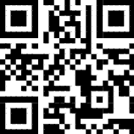 | Information for candidates  Non examination assessments
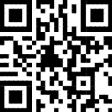 | Information for candidates  Using social media and examinations/assessments
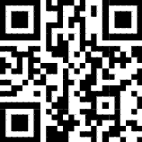 | Information for candidates  Coursework assessments
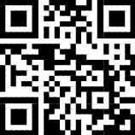 | Information for candidates  On-screen tests
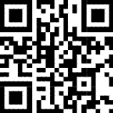 | Preparing to sit exams
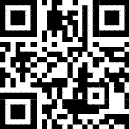 | Information for candidates  Privacy Notice

Alternatively, all documents can be found on the JCQ website:
https://www.jcq.org.uk/exams-office/information-for-candidates-documents/

