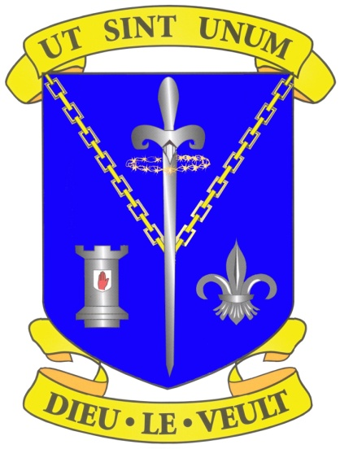
Introduction
Sixth Form at St Louis Grammar School continues to grow, with a current enrolment of 329 students. In addition to the high percentage of internal students who return to St Louis after studying GCSE level, an increasing number of external students are choosing to join St Louis to study A Levels.
High results and excellent pastoral care, coupled with an extensive enrichment and CEIAG programme, makes St Louis an increasingly popular choice.
We invite you to take a look at our admissions criteria and application process for entry to Sixth Form.

Sixth Form Admissions
St Louis Grammar School Ballymena

Admissions Criteria:
St Louis Grammar School admits students based on their performance in GCSE.
The minimum entry requirements are detailed below:
- Students should have achieved a minimum of seven GCSE subjects at Grades A*-C.
- Students should have a minimum of a grade B in the subject which they wish to study for AS or A Level.
- For some subjects there will be enhanced criteria and admission to this subject will be dependent on whether applicants meet the criteria.
- In an instance when a subject is oversubscribed students will be ranked in accordance with GCSE results and those with higher GCSE results will be given first preference.
- For entry for September 2023 students can only begin a two year course if they have a date of birth on or between 2 July 2006 and 1 July 2007.

In addition to the above criteria, a history of high attendance and good conduct are essential for entry to Sixth Form at St Louis.

